DATE: 29.03.2019
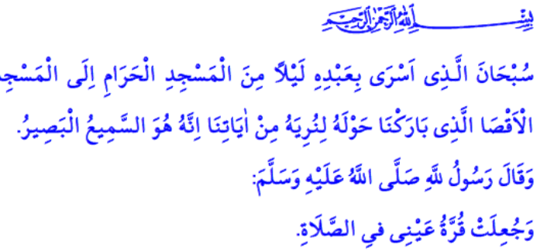
LAILAT AL-MI’RAJ
Dear Muslims!
As observed in all periods of history, the polytheists of Mecca also knew no bounds in torture and oppression. They applied social and economic boycott against Muslims in order to prevent the invitation to Islam. Shortly after the boycott ended, the Prophet Muhammad (saw) lost both his uncle Abu Talib who had protected him and his beloved spouse and our mother Khadijah who had been his supporter during troublesome days. Thinking that our Prophet Muhammad (saw) became unprotected with their demise, the polytheists increased the oppression and torment which they deemed he (saw) deserved. Looking for a remedy, the Messenger of Allah (saw) went to Ta`if in order to convey the message of Islam. However he was exposed to insults there as well. Moreover, he was lapidated and his blessed feet drenched in blood. During such a period when he (saw) was in need of consolation, the Almighty Allah (swt) guarded his Beloved one and granted al-Isra and the miracle of Mi’raj to him (saw).
Honorable Believers!
Allah the Almighty (swt) states in the verse I have recited at the beginning: “Exalted is He who took His Servant by night from al-Masjid al-Haram to al-Masjid al-Aqsa, whose surroundings We have blessed, to show him of Our signs. Indeed, He is the Hearing, the Seeing.”
Al-Isra is the night journey of our beloved Prophet (saw) from Masjid al-Haram in Mecca to Masjid al-Aqsa in al-Quds. Lailat al-Mi’raj is the name of the acceptance to the highest level from Masjid al-Aqsa.
Dear Muslims!
The Messenger of Allah (saw) returned from Lailat al-Mi’raj with three great gifts to his Ummah. First of these gifts is the five daily prayers (salat), which is called by the Prophet Muhammad (saw) as “the light of my eye”. Prayer is the manifestation of the powerful faith link between Allah (swt) and the servants. It is the spiritual rise of the believer who turns toward the qiblah and prostrates before Allah. Prayer does not consist of certain gestures and moves only. Rather, it is a worship surrounding human both in physical, mental and moral aspects. A person who performs prayer is the one who is expected to have good ethics and to be honest, modest, compassionate, and just. Therefore, Allah (swt) states, “Indeed, prayer prohibits immorality and wrongdoing.”
Another gift of al-Mi’raj is the last two verses of Surah al-Baqarah, which we know as “Amanar Rasul” and read after the ‘isha prayer every day. These Qur’anic verses remind us the principals of faith, consciousness of servitude and the sense of responsibility. These verses state that we will give account for whatever we do in this world, and teach us how to pray and invoke Allah.
The last gift of al-Mi’raj is the herald that sins of the ones among the Ummah of Muhammad (saw) shall be forgiven if they do not associate any partners to Allah (swt) and will finally be rewarded with Jannah.
Honorable Muslims!
The bleeding trust of al-Mi’raj in our hearts is al-Quds and Masjid al-Aqsa. Called as “the land of peace and salvation (Jerusalem)” under the rule of Muslims for centuries, al-Quds now has been transformed into a land of occupation, oppression, violence, and sorrow. Those who disregard freedom of worshipping and violate the immunity of temples on one hand prevent the believers from worshipping in Masjid al-Aqsa and on the other hand brutally murder the innocent Muslims while worshipping in the mosque in New Zealand during the Friday prayer.
It should not be forgotten that any despotism cannot prevent Muslims from worshipping in unity and peace in al-Quds, Masjid al-Aqsa, and in all other mosques of the earth. The oppressors who attempt against tranquility, peace and hope will be the victims of the fire that is lighted by themselves. In this regard, Allah the Almighty (swt) expresses in the Holy Qur’an: “And who are more unjust than those who prevent the name of Allah from being mentioned in His mosques and strive toward their destruction. It is not for them to enter them except in fear. For them in this world is disgrace, and they will have in the Hereafter a great punishment.”
Dear Believers!
May Lailat al-Mi’raj conduce to clearness in our minds, freshness in our hearts and peace in our lives. Let us stand up (for qiyam) shoulder by shoulder by obeying wholeheartedly to the call of Allah (swt) for prayer. Let us prostrate (sujud) with the fruitfulness of Lailat al-Mi’raj. Let us remember the honor of faith and the responsibility of being a servant once more. Let us not refrain our hope and pray for reaching to the nights of Lailat al-Mi’raj when al-Quds and Masjid al-Aqsa are free.
May Allah (swt) let the Lailat al-Mi’raj that we will experience in the night from next Tuesday to Wednesday conduce to the unity and togetherness, the rise and elevation of the Islamic world.

Isra, 17/1.
Muslim, Iman, 279.
Nasa’i, Ishrat al-Nisa’, 1.
Ankabut, 29/45.
Baqarah, 2/114. General Directorate of Religious Services

